Georgia State Parks and Historic Sites
Weekend Summary
04.20.2020

Severe Weather:
- Fortunately, our sites did not experience storm damage the night of April 19, except George T. Bagby which had approximately 15 trees down. Florence Marina sent two Park Rangers and a skid steer to assist with debris removal.

Crowds:
- Many sites experience high day-use and hiker visitation on Saturday including Black Rock, Chattahoochee Bend, Cloudland, F.D. Roosevelt, Ft. Mountain, High Falls, James H. Floyd, Red Top, Reed Bingham, Sweetwater Creek and Tallulah Gorge.
- Sites successfully utilized their modified operating plan and temporarily closed day-use areas including: Chattahoochee Bend, Cloudland Canyon, Fort Yargo, High Falls, Providence Canyon, Sweetwater Creek and Tallulah Gorge. Red Top and Wormsloe also reached full capacity and limited incoming traffic.
- Director Cown, Region Manager Yeager, Captain Burgamy and Corporal Ben Cunningham met with Dade County leaders on Thursday to discuss the Modified Operations Plan at Cloudland.
- Other site activity:
  - Black Rock redirected parking from the TN Rock trailhead parking area to the visitor center parking area due to max capacity at the trailhead.
  - Don Carter had a horse rider fall and need assistance on Saturday. Staff carried the rider out with the RTV.
  - Sweetwater Creek had an issue with cars parking along the Cedar Terrace and Mt. Vernon. Social distancing was an issue on the Red Trail.
  - Several citations issued at Tallulah Gorge by LED.
  - Victoria Bryant broke up a group of 15 at the sliding rock.
  - Fort Yargo State Park had assistance from LED as they responded to a male subject at the beach on 4/16 for crude behavior. On 4/17, staff had a brief search for a child.
  - Panola had a brief missing person report on 4/17. The subject was located off-site.
  - At Sweetwater Creek on 4/15 park rangers received a call at 8:30 p.m. about 3 lost hikers. The subjects were located 2 miles off park property on private trails. They were returned to their car at 9:45pm. On 4/17, LED caught and gave a citation to a subject on an ATV in the Riverside portion of the park.
  - At Red Top Mountain State Park on 4/15-16, LED Officers investigated and worked with local LEO’s on arresting a male subject who broke into the Iron Hill trailhead park pass box.
  - On 4/17, Mistletoe staff asked for the removal of 3 dogs from the beach, while additionally LED asked for the removal of 2 dogs. On 4/17, staff asked for the removal of 10 chairs from the beach area.
  - On 4/17, the Watson Mill Bridge State Park staff had to break up one group of over 10 motorcycle riders at the day-use area.

- Golf Course activity
  - Laura S. Walker and Gordonia had good play on Saturday with lower numbers on Sunday due to weather and over $7,000 in revenue for the week.
  - Hard Labor, Richard B. Russell and Victoria Bryan experienced high volumes of play over the weekend, especially on 4/18. For 4/18 only, The Creek at Hard Labor State Park earned $6,700 in overall golfing revenue; Arrowhead at Richard Russell State Park had 122 rounds played with total golf revenue earnings of $5,178; Highland Walk at Victoria Bryant State Park had 126 rounds played and revenue earnings of $4,200.

- Boat ramp activity
  - Florence Marina State Park boat ramp closed at 7:30 am on Saturday and remained at full capacity until 2:30pm.
  - The boat ramp at Fort McAllister had to be closed several times Saturday due to capacity.
  - The Richard B. Russell State Park mega ramp closed at on Saturday at 9:30 am and remained at full capacity until 3:30 pm. During this time, the site deferred boaters over to the Olympic rowing ramp on the park, which never reached full capacity.
  - Mistletoe did use overflow parking for the boat ramp around 3:30pm.

Staffing issues:
- As of today, the Division as a whole has 128 part-time and full-time staff out due to COVID-19 related reasons. A total of 10 employees have tested for COVID-19 and 3 were positive, 4 negative and 3 are awaiting results. A total of 39 Camp Host Units (approximately 78 people) have left due to COVID-19 and 24 units have been replaced.
- Several parks are seeing some employees returning to work from self-quarantine, but many remain short-staffed and some host positions being filled. One host is seeking medical attention.

Positives
- The new modified operating plans are working successfully to assist with the management of crowds, traffic and social distancing. We will continue to modify and improve as needed. Staff stepped up and handled a very busy day on Saturday with no issues or complaints that we are aware of. Very thankful for the staff teamwork and professionalism! LED is extremely helpful with crowd and traffic control. Good and helpful communications with Marketing to get temporary closures posted on the website.
- The Creek at Hard Labor Creek State Park has seen more children coming out playing on the course with their parents and grandparents than compared to other seasons.

- Sites are seeing a lot of new visitors there are many people taking advantage of the lakes for fishing.
- The lake at Laura Walker is back to full pool with heavy usage. The Friends of Laura S. Walker donated a check for $1,000 to the park to help purchase Covid-19 related supplies.
- Website continues to see increased pageviews. For 4/13-4/19:
  - Alerts - 50,045 pageviews
  - eRanger - 1402 pageviews
  - Reservations page - up 32% YoY
  - Total Website Pageviews - up 63% YoY
- The new eRanger video continues to be a tremendous success. There were 123,700 views on Facebook this past week, and 476,700 since it launched March 25.
- HPD Staff attended a conference call with FEMA to further revise existing streamlined emergency procedures in place for compliance with Section 106 of the NHPA to better address the specific challenges presented by COVID-19.

Challenges
- High day use traffic is the biggest issue for staff to address. The high day use traffic increases crowd controls and cleaning needs. Fortunately, the modified operating plans are assisting.
- The burden of the weekend crowds is causing additional stress on already short staff and the overuse is starting to show at Red Top and Sweetwater Creek. Staff at both sites are having a hard time managing routine tasks like trail trash pick-up and mowing grass around overnight facilities. At Sweetwater Creek the majority of guests want to hike the Red Trail no matter where they park. This has increased foot traffic on Mt. Vernon road from parking lots at the bait shop and south causeway areas. Road shoulder parking improved at Sweetwater Creek with multiple barrels in place, but there are still parking issues on Mount Vernon Road that the staff, LED, and the region are working through. Sweetwater has received the most complaints of hikers not social distancing and trashing the trails.
- Skidaway is seeing increasing numbers of people remaining on trails after dark, dogs off leash, speeding, alcohol violations, and attempts at camping in unauthorized locations.
- Many locals that use Wormsloe are not paying at the collection box.
- Several sites have had visitors remove fencing or closure devices on playgrounds to use them.

COVID19 Financial-Occupancy Impact thru April 19th

Weekend Occupancy:

Past Weekend:
Overall, we only saw a 4% drop in occupancy for all reservables. Last week it was a 17% decrease and the week before that it was 23%. Cottage occupancy dropped 36%; last week it was at a 43% decrease. Yurts and camping both saw an increase over last year. Camping increased 1% to 78% and yurt occupancy was at 95%, up from 90%. Please note last year during this weekend it was rainy all across the state, where this year had good weather Saturday and rain on Sunday.

PAST WEEKEND | April 19/20 | April 17/18
OCCUPANCY | FY19 | FY20 | Difference
All Reservables | 69% | 65% | -4%
Camping | 77% | 78% | 1%
Cottage | 85% | 49% | -36%
Yurt | 90% | 95% | 5%

Revenue:

For the month of March through April 19th, we have seen a decrease in revenue of 37% or a loss of $2.1 Million. This past week, April 13th – 19th, we actually had a 3% or $21,000 increase in overall revenue. This is the first time we have seen an increase since the COVID situation began.

ParkPass has decreased 12% during this timeframe. This is the same overall % of decrease as last week. We are starting to see parkpass sales improve, for instance, this past week parkpass sales only dropped 10% compared to last year/same week. 20% of the parkpass collected in April has been from customers utilizing the QR code and purchasing daily parkpass online.

Golf had a significant increase this past week, with a 17% revenue improvement over last year. This pushed golf to a 3% increase overall during this time period.

For overnight accommodations – camping revenue is now at a 0% change, it was at a 15% decrease last week. This past week, camping revenue actually doubled from the previous year. Cottages are now at a 58% loss for March/April, it was at a 66% decrease last week; yurts are at a 38% loss, 2nd week that yurts have increased revenue.

We are seeing the revenue significantly improve over last week due to several reasons:
- Camping and yurt occupancy both actually had an increase over last year during this past week.
- We are now collecting all revenues at the time of booking, no longer just a one-night deposit. This change is going to assist us during this time but will make it difficult to project future revenues.
- And again, the number of cancellations is starting to significantly slow down. Although we do need to keep in mind, that for future refunds, we will be refunding the revenue for the entire stay, rather than just a one-night deposit.

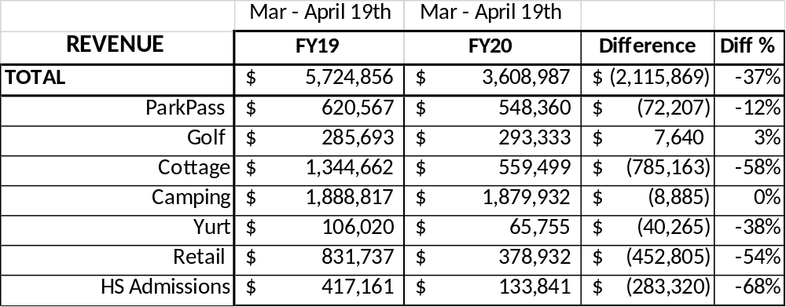

Cancellations/Refunds:

Through this morning, we have had 20,000 cancellations, including $1.7 Million in actual refunds and a loss of future revenue of $6,500,000.

This is 2,000 more than last Monday, when we were at 18,000 cancellations. We continue to see a significant drop in the number of cancellations. We were trending at about 4,000 – 5,000 cancellations a week, for the past two weeks the average is 2,000.

Last year during this same time period, we had 5,000 cancellations, including $249,000 in actual refunds and a loss of future revenue of $1.2 Million.

So, total cancellations have increased over 15,000 or 300% and the amount of refunds have increased $1.5 Million.

